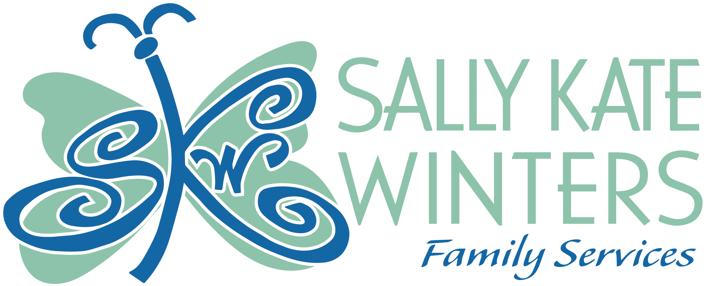 Transforming Lives.

Board of Directors
Jessi Sugg, President
Mark Jackson, V. President
Cheryl Harris, Secretary
Karen Mooney, Treasurer
Jamey Ballard
John Freeman
Kim Hood
Rebecca Hudson
Rosie Jones
Steven Woodruff Jr.
Amy Crowley
Collen Hudson
Alex Jackson
Kristen Williams
Carla Golden
Summer Joy Brooks

Cindy Tucker, BSW
Executive Director
Natalie White, MS, LPC-S
Clinical Program Coordinator
Cynthia Mathews
Case Manager
Genika McGee, MSW, CMHT
TLP Advisor
Kelly Michael, LSW
Outreach Coordinator
Jessica Robinson, BSW
TLP Life Skills Coach
Larina Sparks
Shelter Supervisor
Pooja Shaunak, MBA
Financial & Grants Manager
Tessa Andersen
Forensic Interviewer
Santiica Doss, MSW
MDT Coordinator
Phyllis Jacobs
Office Assistant
Nataya Bluitt
MDT Facilitator
Tinley Wharton
Victim Advocate

Direct-Care Staff:
Creacy Fulton; JoAnn Petty; Parthina Rogers;; Doris Bigbee; Kristina Dixon; Chandra Waldrep, Shelia Bush; Lakita Goss, and Yanci Lavender

Volume 113, July-September 2025

A MESSAGE:
Dear Friends, Supporters, and Volunteers,
As the summer transitions into autumn, I'm honored to share an update on the vital work you've made possible throughout July, August, and September. The third quarter was a time of immense growth, and every milestone reflects the power of our community working together to advance Sally Kate Winters Family Services.
Our work is powered by people. We are deeply grateful for every hour volunteered and every dollar donated. A massive thank you to our Volunteers! During this quarter, our dedicated volunteers contributed over 179 hours of service, which is equivalent to providing two full months of tutoring support for eight youth. They helped organize our clinic and redecorate our RHY room. Additionally, they led activities such as swimming, tie-dyeing shirts, movies, skating, and planting flowers. Volunteers provided cakes for youth birthday celebrations, donated hygiene products, clothing, and food, set up furniture for the Shelter and TLP, and painted and organized spaces for our programs. This commitment assisted the organization and made an incredible impact.
We held our Christmas in July and our signature fundraiser for Annual Christmas shirts, tiles, and ornaments also began. This year, every shirt, tile, and ornament sold will support our youth programs, bridge critical gaps and ensure effective outreach. For the first time, one of our youths designed our Christmas Shirts. I hope you can get a shirt, tile, or ornament this year and contribute to this meaningful cause.
Through presentations on Mandated Reporting and Safe Place, we helped organizations and groups understand the importance of safety. We taught how to recognize signs of unsafe situations and how to seek help. These conversations are an important part of our ongoing mission. We aim to protect children and empower our community with knowledge to prevent child abuse. As a result, over 200 individuals were trained, further extending child safety measures across various community activities and consistently reinforcing the safe environments we strive to create.
We are proud to highlight our partnership with United Way and His Way; their support is instrumental in providing resources, grants, and expertise.
As we enter the final quarter of the year, our focus shifts toward Community Awareness and youth outreach, as well as preparing for the end-of-year giving campaigns, which are crucial for our sustainability. We are gearing up for Giving Tuesday on December 2nd. Mark your calendar and pledge to make a difference on this special day. Your support is vital, and together we can continue to drive our mission forward.
Thank you for being the driving force behind everything we do. Your belief in Sally Kate Winters Family Services is our greatest asset, and we look forward to sharing more milestones with you soon.

With Appreciation,
Cindy Tucker
Executive Director

MEMORIALS
In Memory of Bobby Bounds  By Jim & Ladonna Helveston  In Memory of Michael D Jones  By Willie Hightower & Carolyn H Hood  In Memory of Bobby Berry, Pete O’Shea, Charle Mager, & Tommy Briggs  By Holly Hitt  In Memory of Henry Tex & Michael J. Brown  By Barbara & Tex Brown  In Memory of Phillip McCarty  By Willie Hightower & Carolyn Hood | In Memory of Peggy Winfield  By Willie Hightower & Carolyn Hood  In Memory of Geraldine Lee  By Elizabeth & Eugene Bailey  In Memory of multiple individuals  By Gale Griggs  In Memory of Bobby Stockton  By Mike & Angie Bunch  In Memory of Stephanie Kay Travis  By MS Eye Care | In Memory of Ruby Barton  By Larry C Barton  In Memory of Ginny Lee Coggins  By Charles Coggins  In Memory of Bill Manscoe  By Deborah & Leonard Dichiara, Vicki Collier, & Larry & Mary Fretz Sr.  In Memory of Larry Edgar Root  By Willie Hightower & Carolyn Hood

CASH CONTRIBUTORS
Robbie & Percy Bryant  Eugene & Katy Suan Allen  Carolyn Wray Calvert  Victoria Luke  Clarence Bohanon  The Episcopal Church of the Resurrection  Miskelly Furniture  State Nutrition | International Paper  Karen Mooney  United Way of the Golden Triangle  Ann Jameson & Deborah Chandler  Robbie & Percy Bryant  John & Deborrah Wray  First United Methodist Church | Andrew DeSantis  International Paper  Monroe County Board of Supervisors  Ed & Tonda Riley  La Fiesta Brava  Jean & Shavonne Terry  Alvin & Mary Quinn
HONORARIUMS
In Honor of Friends
By Kyle Chanlder IV

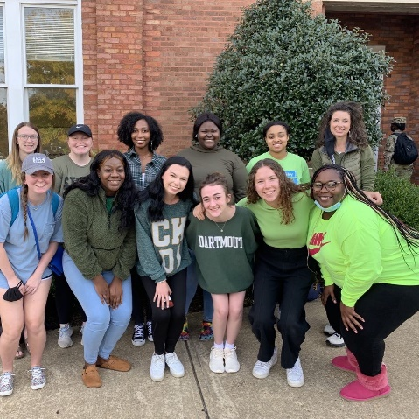

IN-KIND CONTRIBUTORS
Pooja Shaunak  Bessie Cox  Robin Matthews  Brandy Malone  Fredrick & Dorothy Smith | PJ Jacobs  Courtney Smith  Dorothy Smith  Antrianna Matthews | Tae Harris/ The Harris Initiative  Cynthia Duncan  Elizabeth Hammond  Sarah Powell

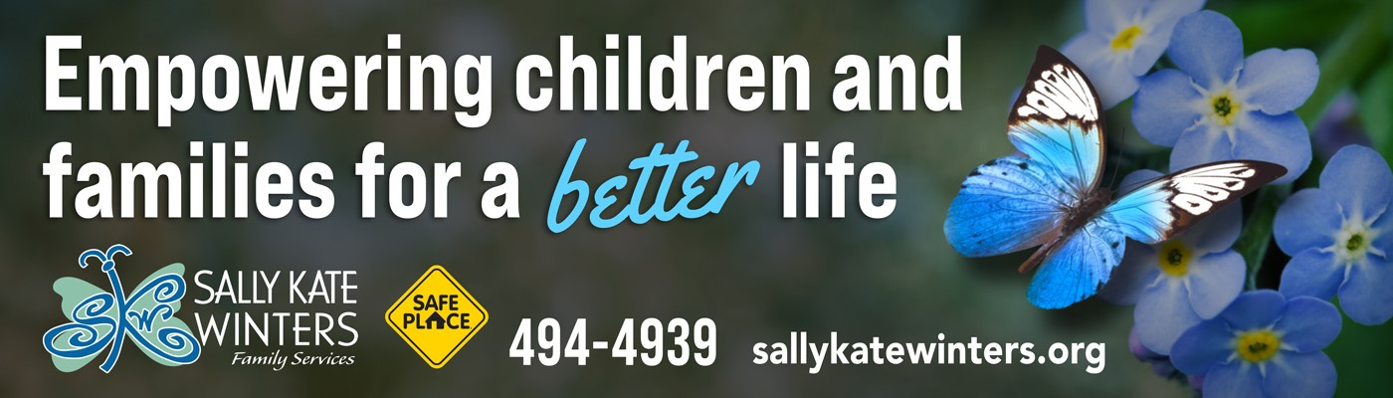

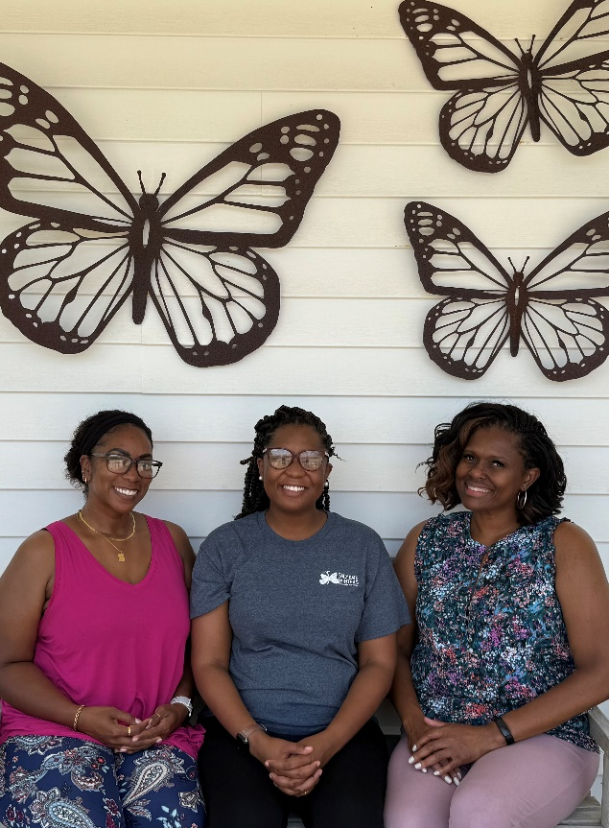
“Transitional Living Program”
This summer our Transitional Living Program had a waitlist, which hasn't happened since 2014! The work that these three do day in and day out is remarkable!!
Great Job!!
Genika McGee, CMHT, MSW, TLP Advisor
Jessica Robinson, BSW, TLP Life Skills Coach
Natalie White, MS. LPC-S, Clinical Program Director

Sally Kate Winters Family Services Transitional Living Program (TLP) provides housing, skills training, and support services to youth ages 16-22 on a first come, first serve basis for up to 18 months. The purpose of the program is to help participants who are homeless, at risk of homelessness, or need transitional living services to become independent and achieve self-sufficiency. The program is completely voluntary and there is no cost.

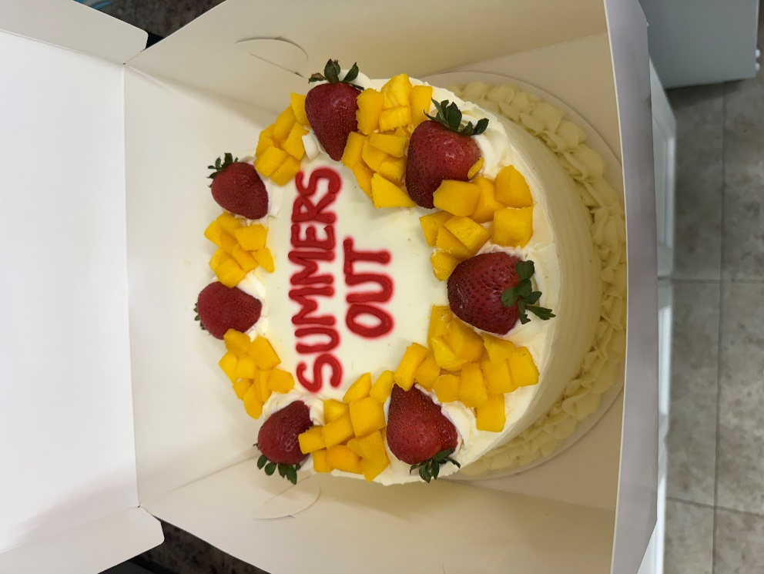

“Summer”
Summer came and went too fast! The youth had fun with different activities and ended the summer with a party!

“Fundraising”
We have some fundraisers we have coming up this winter! We will be selling popcorn and having a Year End Giving Campaign. Follow us on our social media pages, join our email newsletter, or you can always call to see what we have going on!

“Volunteers”
Episcopal Church of the Resurrection in Starkville have been volunteering with our programs, helping us to get organized. They also came and re-did one of our TLP rooms. We are so grateful for them and the partnership we have created!

You can contact our office if you or your group are interested in volunteering with our agency!
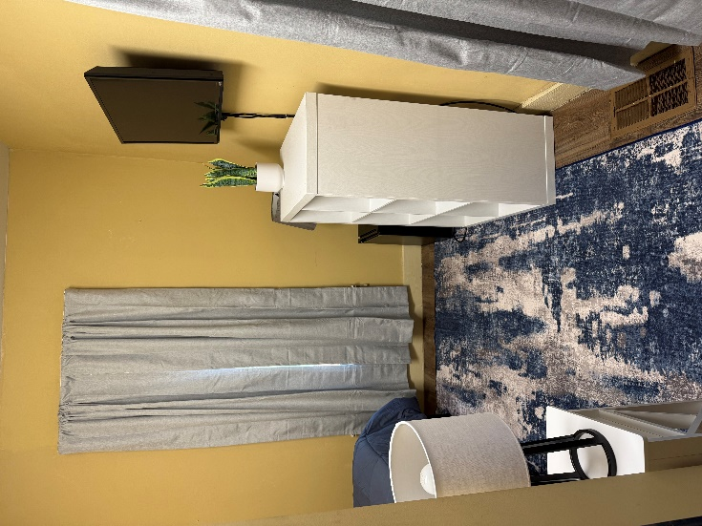
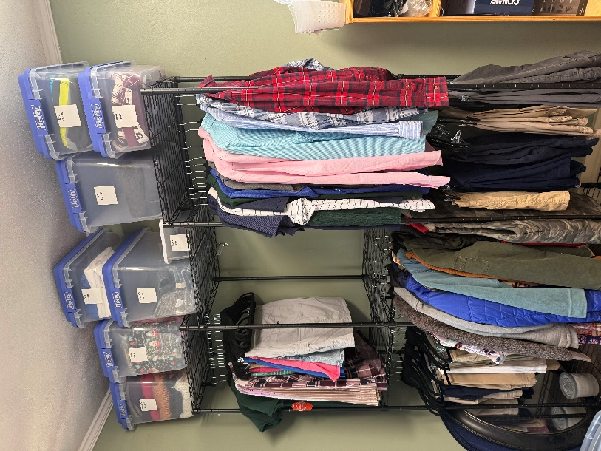

“Donations”
Donations can be made to Sally Kate Winters Family Services through in-kind; needed items or gently used items. Also, cash donations can be made in honor or in memory of someone and you also have the option to give through the Children’s Promise Act Tax Credit. Thank you to The Harris Initiative for donating hygiene items and to Mitchell Distributing for donating $5,000 through the Tax credit.

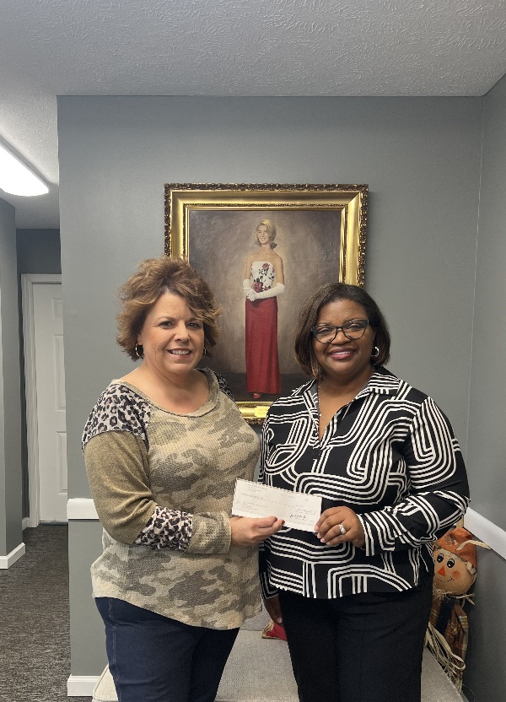
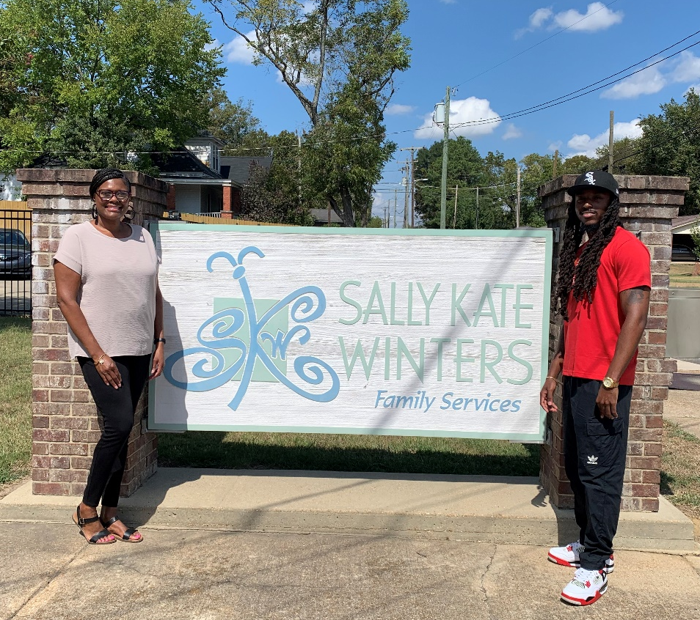

The Harris Initiative
Mitchelle Distributing
PROGRAM UPDATE
For July, August & September 2025
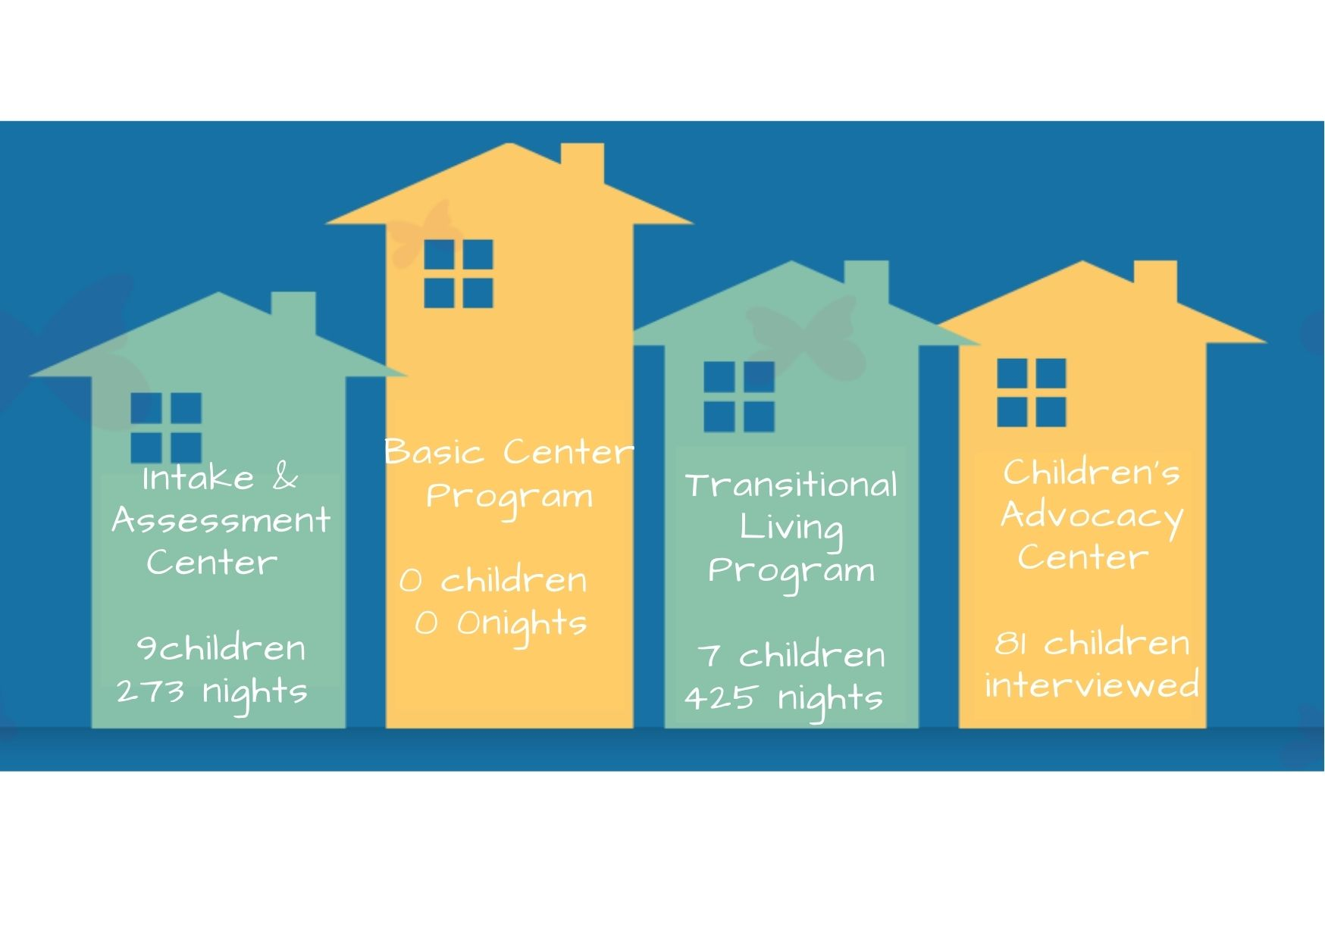

Intake & Assessment Center
Shelter services were provided for 9 children who received a total of 273 nights of service. The children represented ages 10-17, with neglect, and family violence being the reasons for placement. 4 counties were represented through shelter placement by the Mississippi Department of Child Protection Services.

Basic Center Program (BCP)
BCP shelter services were provided for 0 youth, for a total of 0 nights of service. 0 crisis calls was managed by RHY staff, providing resources for youth in need of services. A total of 30 Safe Place Sites are available in a 5 county area to assist youth in crisis and connect them to local services.

Overnight Respite Program
Overnight respite services were provided for 0 foster care children for a total of 0 nights of service. The Overnight Respite Program offers foster parents a short respite from providing 24-hour care for children in the state foster care system.

Transitional Living Program (TLP)
TLP services were provided for 7 youth for a total of 425 nights of service. 6 counties were represented through the services offered by TLP. Youth participated in life skills classes, volunteer activities, educational enrollment, and employment as part of the TLP program.

Children’s Advocacy Center(CAC)
CAC services were offered for 81 children and their non-offending caregivers. Services include forensic interviewing, victim advocacy, on-site mental health, and referrals for other services. These children represented child abuse cases involving alleged sexual abuse, physical abuse, and witnesses to a violent crime. 12 counties were represented through the services offered by the CAC, along with monthly Multi-disciplinary Meetings and case review in the counties of Clay, Choctaw, Lowndes, Oktibbeha, and Noxubee.

Sally Kate Winters Family Services provided a total of 2,094 meals for children in need during this quarter.

A total of 68 individuals donated 199 volunteer hours during the quarter.

801 North Division Street
Post Office Box 1233
West Point, MS 39773
phone: 662.494.4867
fax: 662.494.0870
website: sallykatewinters.org

Empowering children and families
to seek and experience an improved
quality of life.

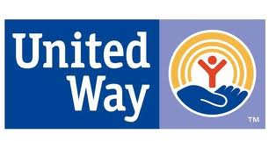

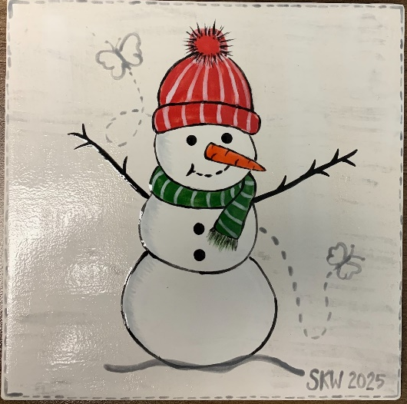
“Christmas Fundraiser”
We will have limited Christmas Shirts for sale for anyone who may have missed the pre-sales. We have sizes S-XXXL all $25 each Youth S-XL all $20. We also are still selling tiles/ornaments until they are gone $16 each. Help us sell out!!!

